**RStudio Data Entry Protocol**

1. 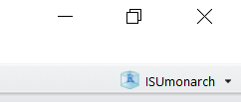Open RStudio and make sure the “ISUmonarch” project is open.

You should see “**ISUmonarch**” in the upper right hand corner

1. 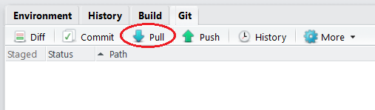Perform a “**Pull**” in order to make sure that your computer is up to date with the GitHub repository for the project. Press the **pull** button under the “**Git**” tab in the top-right portion of RStudio.

**\*\*Always do this as soon as you open RStudio\*\***

1. 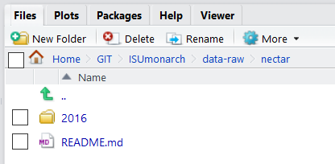Decide what type of data you are entering (**nectar, bees, monarch, daubenmire,** or **landscape**) and make sure you are connected to the correct directory on your computer. It should be located in ***GIT/ISUmonarch/data-raw/.*** In this example, I was entering nectar data, so I am connected to the **nectar** folder within ***GIT/ISUmonarch/data-raw/***
2. Look at the data sheet you will be entering and note the date it was recorded and make sure that RStudio is directed to that folder. The directory would be: ***GIT/ISUmonarch/data-raw/”year”/”month”/”day”***. In this example, I was entering data from **year 2016, month 06, day 27.** If any particular date doesn’t exist as a folder yet, simply create a new folder.

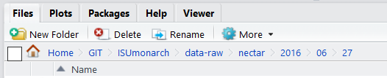

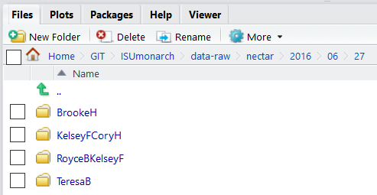

1. On the data sheet you will be entering, look at who recorded the data in the space next to “**Observer:”** and take note of it. In the directory from the previous step: ***GIT/ISUmonarch/data-raw/”year”/”month”/”day”,*** you will be creating folders titled with the **first name and last initial** of the person who observed the data on that specific day.

* If there are multiple names listed next to “**Observer:”** type all of them but order them **alphabetically by last initial**
* If there is a team listed next to “**Observer:”** type the first name and last initial of whoever’s team is listed. For example, **Team Teresa** would simply be **TeresaB**

1. 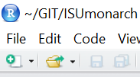After making sure RStudio is in the correct directory, it’s time to create a new text file and start entering data. Press the “**New**” button in the top left portion of RStudio and select “**Text file**” which should open a blank, untitled document below.
2. 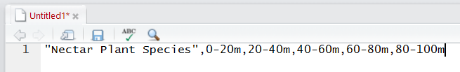This blank document is where you will be entering data. The first line of this file will be consistent with every data sheet of a given category (**\*\***with some exceptions), depending on what category you are entering (nectar, monarch, landscape, etc.) For example, all of the text files for **nectar** data begin with “Nectar Plant Species” followed by the transect length/section intervals:

**“Nectar Plant Species”,0-10m,10-20m,20-30m,30-40m,40-50m,50-60m,60-70m,70-80m,80-90m,90-100m**

**\*\***Make sure to change the lengths accordingly for any transect that isn’t 100m with 20m sections.

* For example, this site only had an **80m** transect:



* And this site only had a **50m** transect **but** with **10m** sections:



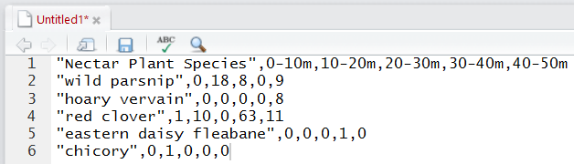

1. Once the first line has been typed, move to the second line and begin entering the plant-specific data. Begin by entering quotes (“) and typing the common name of the first listed plant on the data sheet. After typing the **common name** in quotes, enter the **total for each section of each specific plant** after a comma. The commas separate each section from each other in order. So for **“wild parsnip”**, 0-10m has **0**, 10-20m has **18**, 20-30m has **8**, 30-40m has **0**, 40-50m has **9**

Do this for every listed plant on the nectar sheet.  
Do not capitalize anything or use any dashes or apostrophes in species names

If a site had no nectar plants at all, just type the first line and save as-is.

**\*\*ALWAYS double check that everything is entered correctly before saving\*\***

1. Now it’s time to save, commit, and push the update to the online repository. To save, press the **save** button and a window will popup asking you where to save it. Choose the correct directory at the top of the window.

**\*\*ALWAYS** make sure that you choose the correct directory based onthe ***data,* *date*** and ***observer*** recorded on the data sheet: in order of ***“data”/”year”/”month”/”day”/”observer”***



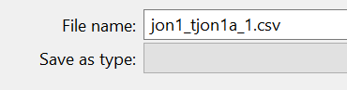

Name the file according to the site code found on the sticker in top right corner of the data sheet. It should be typed as follows: **site_transect_round**

In this example, the site was **jon1**, transect **tjon1a**, round **1**. End the name with the file extension **.csv**

**\*\*BEFORE you save,** once again make sure that you chose the correct directory based onthe ***data,* *date*** and ***observer*** by looking on the data sheet. Press save if all is well.

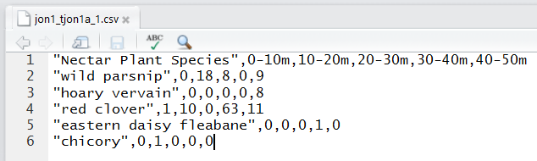

After saving, the “untitled” document should be **updated and named** with whatever site_transect_round was just entered, as seen with the example.

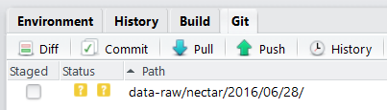

There will also be a new item under the Git tab in the top-right window of RStudio with **two yellow question marks with a box to check** next to it. This simply means that RStudio notices there is a new file on your computer that isn’t consistent with the online repository.

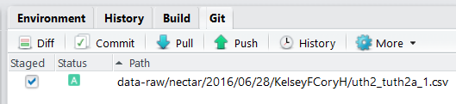Check the box and the yellow question marks will disappear to be replaced with a green “**A**”. Now press the **“commit”** button to open a new screen shown below. Performing a commit means it is documenting the new data into the online repository with information about what it is.

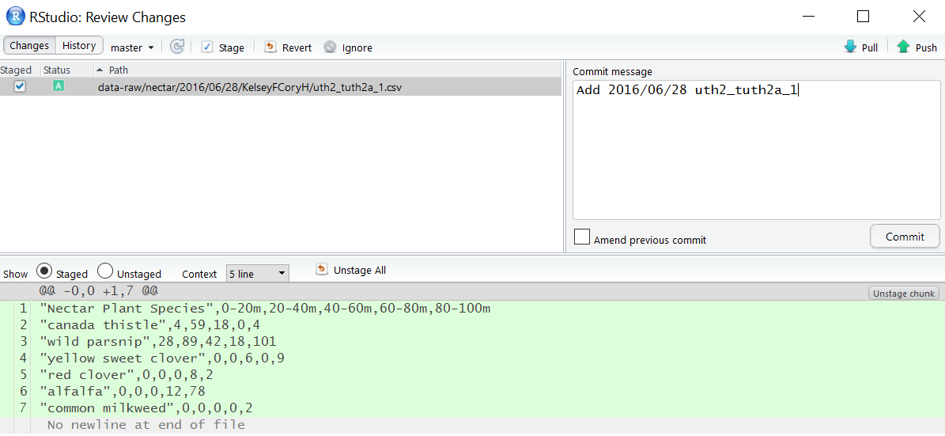

This screen shows everything about the new data entry you created. It is important to document exactly what you did and type it in the **“Commit message”** window in the top right. For any data sheet being entered, the commit message should be formatted simply as:

**“AddYYYY/MM/DD site_transect_round”**

* If you did something other than enter new data, such as altering an existing file or adding something other than data, use the first line of the “Commit message” to breifly say what you did (50 characters or less), press enter twice to go two lines down, and describe in detail what you did with more text.

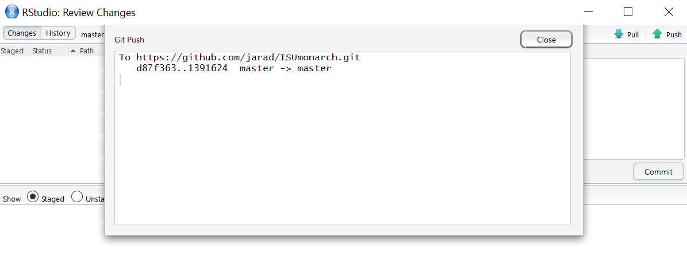After the “Commit message” has been typed, it’s time to press **commit** to document the change. A small window will pop up showing the process completed with some text. Press close on the popup window.  
  
Finally, it’s time **push** the new data commit into the online repository. Press the **push** button in the top-right corner. Another small processing-window will popup and, once complete, will show a message similar to what’s shown below.

Close the popup window. At this point, press the **pull** button. This simply checks and pulls any updated files from the online repository to make sure your local directory is consistent with the online repository. Since you just pushed the new commit, it should say **“Already up-to-date.”** It’s important to remember to commit and push after every single new data sheet (or every time you stand up from your chair) so that Github can document every little change we make to the repository and maintain consistency across different devices and people.

**Some important things to remember:**

PULL WHEN YOU SIT DOWN, PUSH WHEN YOU STAND UP

ALWAYS PULL every time you open up RStudio to begin  
  
Make sure to COMMIT and PUSH before you quit entering data for the day

Do NOT capitalize anything  
  
Do NOT put dashes in species names

DOUBLE CHECK everything before saving, committing, and pushing new data entries

Be CONSISTENT with everything you do